**--------------------------------------- CÁLCULOS PARA OS DADOS DO IPAQ -----------------------------------**

[1] *-- Wednesday, January 19, 2022 -- 15:25:28*

**F tests -** ANOVA: Repeated measures, within factors **(AF LEVE IPAQ)**

**Analysis:** A priori: Compute required sample size

**Input:** Effect size f(U) = 0.6143374

α err prob = 0.05

Power (1-β err prob) = 0.80

Number of groups = 1

Number of measurements = 5

Nonsphericity correction ε = 1

**Output:** Noncentrality parameter λ = 15.0964176

Critical F = 2.6059749

Numerator df = 4.0000000

Denominator df = 40.0000000

Total sample size = 11

Actual power = 0.8497140

[2] *-- Wednesday, January 19, 2022 -- 15:30:52*

**F tests -** ANOVA: Repeated measures, within factors **(AF MODERADA IPAQ)**

**Analysis:** A priori: Compute required sample size

**Input:** Effect size f(U) = 0.3779645

α err prob = 0.05

Power (1-β err prob) = 0.80

Number of groups = 1

Number of measurements = 5

Nonsphericity correction ε = 1

**Output:** Noncentrality parameter λ = 13.1428590

Critical F = 2.4706812

Numerator df = 4.0000000

Denominator df = 92.0000000

Total sample size = 24

Actual power = 0.8198166

[3] *-- Wednesday, January 19, 2022 -- 15:33:00*

**F tests -** ANOVA: Repeated measures, within factors **(AF VIGOROSA IPAQ)**

**Analysis:** A priori: Compute required sample size

**Input:** Effect size f(U) = 1.0120729

α err prob = 0.05

Power (1-β err prob) = 0.80

Number of groups = 1

Number of measurements = 5

Nonsphericity correction ε = 1

**Output:** Noncentrality parameter λ = 16.3886649

Critical F = 3.0069173

Numerator df = 4.0000000

Denominator df = 16.0000000

Total sample size = 5

Actual power = 0.8105949

**CÁLCULO PELO GLIMPSE:**

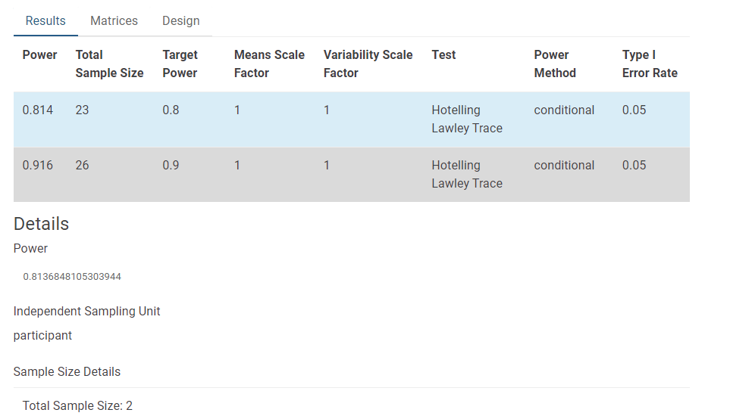

**--------------------------------------- CÁLCULOS PARA OS DADOS DO FLEEM----------------------------------**

[1] *-- Wednesday, January 19, 2022 -- 15:38:46*

**F tests -** ANOVA: Repeated measures, within factors **(AF LEVE FLEEM)**

**Analysis:** A priori: Compute required sample size

**Input:** Effect size f(U) = 0.5155800

α err prob = 0.05

Power (1-β err prob) = 0.80

Number of groups = 1

Number of measurements = 5

Nonsphericity correction ε = 1

**Output:** Noncentrality parameter λ = 13.8227823

Critical F = 2.5497630

Numerator df = 4.0000000

Denominator df = 52.0000000

Total sample size = 14

Actual power = 0.8245349

[2] *-- Wednesday, January 19, 2022 -- 15:40:17*

**F tests -** ANOVA: Repeated measures, within factors **(AF MODERADA FLEEM)**

**Analysis:** A priori: Compute required sample size

**Input:** Effect size f(U) = 0.3086912

α err prob = 0.05

Power (1-β err prob) = 0.80

Number of groups = 1

Number of measurements = 5

Nonsphericity correction ε = 1

**Output:** Noncentrality parameter λ = 12.5783139

Critical F = 2.4402817

Numerator df = 4.0000000

Denominator df = 132

Total sample size = 34

Actual power = 0.8074112

[3] *-- Wednesday, January 19, 2022 -- 15:41:19*

**F tests -** ANOVA: Repeated measures, within factors **(AF VIGOROSA FLEEM)**

**Analysis:** A priori: Compute required sample size

**Input:** Effect size f(U) = 0.2458564

α err prob = 0.05

Power (1-β err prob) = 0.80

Number of groups = 1

Number of measurements = 5

Nonsphericity correction ε = 1

**Output:** Noncentrality parameter λ = 12.3308554

Critical F = 2.4159109

Numerator df = 4.0000000

Denominator df = 204

Total sample size = 52

Actual power = 0.8042001

**CÁLCULO PELO GLIMPSE:**

